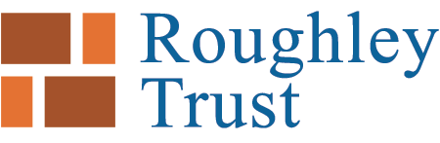 How to apply

We only accept typed applications sent by email. Applications by snail mail are not accepted.

Please complete the form by typing in the boxes, which will expand. The form will show your text in blue in a font size of 12. Please don’t change the font size or colour. Best not to expand the form much beyond 3 sides either.

Email the application form as a Word document, along with a signed letter addressed to the Correspondent on your own headed notepaper, attached as a PDF.

Please choose and email two or three photos (not more) which give a good sense of your project. Send them in a separate email if they are large files.

In your letter don't duplicate information you have given us in the form, but tell us clearly and succinctly why you think the project should be supported. The letter is important.

Other supporting material in moderation may be attached if you wish.

Email to: Correspondent@roughleytrust.org.uk

Adam Wilkins - Correspondent
The Roughley Charitable Trust
562 Kenilworth Road
Balsall Common
Coventry
CV7 7RZ
For Information

We reconcile the Accounts information you give us in the Application form with your Charity Accounts as shown on the Charity Commission website, and will always refer back an Application for amendment if the numbers do not agree.

Give the accounts information for the charity as a whole and not for your project. You can attach your project accounts separately if you want us to see them. Attach your latest Accounts only if they are not showing on the Charity Commission website.

We acknowledge receipt of applications, normally within two weeks.

Eligibility

Trustees welcome grant applications from Birmingham registered charities working in Birmingham with an annual turnover of less than £1M working in any of areas listed on the website. Trustees tend to give priority to applications from smaller or medium size organisations.

Only applications for projects inside the Birmingham boundary will normally be accepted. In some cases Trustees may accept an application from a charity near to the Birmingham border, if the majority of their clients are in Birmingham. This means that applications for projects in Sandwell, Solihull, Wolverhampton, or Walsall for example will not normally be accepted.

Trustees do not make grants to national charities, even if the national charity has a project in Birmingham.

Trustees do not make grants retrospectively; so if you are applying for a specific event, make sure it is after the date of the next Trust Meeting.

Exclusions

Trustees will not accept applications from:

National charities
Birmingham based medical charities
Church fabric appeals
Church based projects which are essentially about the teaching of religion
Community interest companies
Social enterprises
Animal charities

